ACLS Helpful Hints 2015 Guidelines – Revised January 2015
Also see www.heart.org/eccstudent: The code is found in the ACLS Provider manual page ii.
The ACLS exam is 50 questions. Passing score is 84% or you may miss 8 questions. For those persons taking ACLS for the first time or renewing with a current card, exam remediation is permitted should you miss more than 8 questions on the exam. Viewing the ACLS book ahead of time with the online resources is very helpful. The American Heart Association link is www.heart.org/eccstudent has a pre-course self-assessment, supplementary written materials and videos. The code for these online resources is in the ACLS Provider manual page ii. Basic Dysrhythmias knowledge is required in relation to asystole, ventricular fibrillation, tachycardias in general and bradycardias in general. You do not need to know the ins and outs of each and every one. Tachycardias need to differentiate wide complex (ventricular tachycardia) and narrow complex (supraventricular tachycardia or SVT).

BLS Overview - CAB 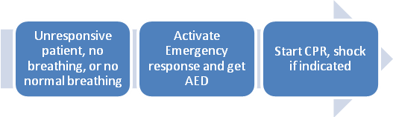
Push Hard and Fast-Repeat every 2 minutes
Defibrillation is part of the BLS Survey
Anytime there is no pulse or unsure - COMPRESSIONS
Elements of good CPR
- Rate-at least 100 - 120, at least 2 inches depth, , recoil
- Compression depth at least 2 inches, not more than 2.4 inches or 6 cm
- Minimize interruptions (less than 10 seconds)
- Avoid excessive ventilation
- Switch compressors every 2 min or 5 cycles
- Compressions during VF produces a small amount of blood flow to the heart.
- If AED doesn’t promptly analyze rhythm: compressions.
- Fatal mistake to interrupt compressions – can compress while charging.
- If you see an organized rhythm, after 2 minutes of CPR have a team member assess carotid pulse.

Stroke
- Cincinnati Pre-Hospital Stroke Scale
- Facial Droop, Arm Drift, Abnormal Speech
- rtPA can be given within 3 hours from symptom onset.
- Important to transport patient to an appropriate hospital with CT capabilities. If CT not available divert to the closest hospital (i.e. 15 min away) with CT
Acute Coronary Syndromes
Vital signs, 02, IV,
12 Lead for CP, epigastric pain, or rhythm change
Recommended dose of aspirin – 160 – 325 mg
Right ventricular MI - caution with NTG

Bradycardia
Need to assess stable versus unstable. If stable, monitor, observe, and obtain expert consultation.
If unstable…
•Atropine 0.5mg IV. Can repeat Q 3-5 minutes to 3 mg Maximum dose is 3mg (Including heart blocks)
• If Atropine ineffective
-Dopamine infusion (2-10mcg/kg/min)
-Epinephrine infusion (2-10mcg/min)
-Transcutaneous pacing

Tachycardia with a pulse
•If unstable (wide or narrow)-go straight to synchronized cardioversion (sedate first)
•If stable narrow complex
-obtain 12 lead
-vagal maneuvers
-adenosine 6mg RAPID IVP, followed by 12mg

Pulseless Rhythms - Cardiac Arrest - CPR
Oxygen, monitor, IV, Fluids, Glucose Check
- 2 minute cycles of compressions, shocks (if VF/VT), and rhythm checks.
- Epi 1 mg every 3-5 minutes (preferred method peripheral IV)
- Infuse IV/IO drugs rapidly during compressions
- NO MORE ATROPINE for Asystole and PEA
- Ventilations - •30:2 Ratio
- Rescue breathing- •1 breath every 6 sec
- If advanced airway- •8-10 ventilations/minute

Shockable rhythms-
-Ventricular Fibrillation (VF)
-Ventricular Tachycardia (VT) without pulse
Biphasic: 120-200J Monophasic: 360J
Refractory – Amiodarone 300 mg, then 150 mg

Non-Shockable Rhythms
-PEA -Asystole

Defibrillation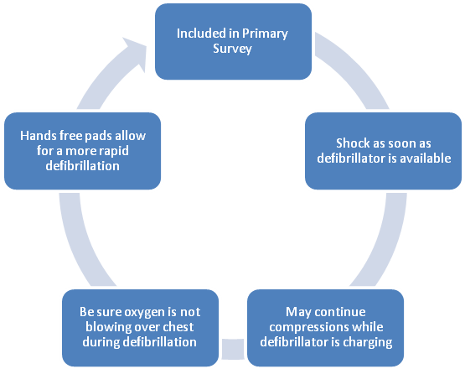
Waveform Capnography in ACLS (PETC02)
- Allows for accurate monitoring of CPR
- Most reliable indicator for ETT placement

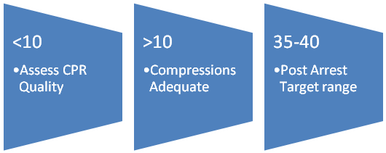
Treat reversible causes (H’s and T’s)
Hypoxia or ventilation problems
Hypovolemia
Hypothermia
Hypo /hyper kalemia
Hydrogen ion (acidosis)

Tamponade, cardiac
Tension pneumothorax
Toxins – poisons, drugs
Thrombosis – coronary (AMI) – pulmonary (PE)
Return of Spontaneous Circulation (ROSC)
Post Resuscitation Care
- 12 Lead,
- Hypothermia if DOES NOT follow verbal commands (target temperature, at least 24 hours, 32 to 36 degrees C)

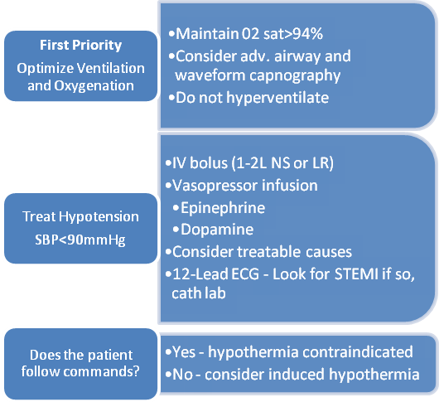
Points to Ponder
- COMPRESSIONS are very important.
- ROSC – return of spontaneous circulation. With out of hospital arrest transfer to facility with PCI.
- Simple airway maneuvers, such as a head-tilt, may help.
- The Medical Emergency Teams (MET)/ Rapid Response Teams (RRT) can identify and treat pre-arrest situations.
- Consider terminating efforts after deterioration to asystole and prolonged resuscitation time and/or safety threat to providers or rigor mortis.
- OPA – measure from corner of mouth to angle of the mandible
- Minimal systolic blood pressure is 90
- IV fluids 1 to 2 liters NS, Crystalloid, Isotonic
- Don’t suction for more than 10 seconds
- Cricioid pressure is not recommended for routine use during cardiac arrest.
- High levels of oxygen can cause oxygen toxicity

